**Date: Jun 5, 2023**

**Project Proposal: Hotel Booking System**

**Team 7 Members:**

* LI, Qian
* Liu, Chang
* Sun, Qianfeng

**Contents**

Title of the project: Hotel Booking System 3

Project Description 3

Technologies Used: 3

Special Features: 4

Challenging Items: 4

URLs/ API calls: 4

Figure: Entity relationship diagram of the Hotel Database 5

Firgure: Case diagram with two actors performing actions 5

Mockups of web pages 6

The homepage: 6

The Rooms: 7

## T**itle of the project:** Hotel Booking System

## Project Description

Our project aims to develop a functional hotel booking system that provides a user-friendly interface for both customers and hotel administrators. The system will allow users to search for available hotel rooms, view details about each type of room, calendar for scheduling, make reservations and manage their bookings. Hotel administrators will have privileged access to the system, allowing them to view the entire hotel booking reservation.

The system will include 3 tables for the database, **Customers (PK: CustomerId), HotelRooms (PK: HotelRoomID)** and **Bookings(PK: BookingID, FK: CustomerId, FK: HotelRoomID).**

## Technologies Used:

* Front-end: HTML, CSS, Javascript,
* Back-end: Node.js
* Database: MySQL
* Additional Libraries: Bootstrap, jQuery, Stripe API payments
* Mockups: Figma
* Entity relationship diagram: <https://app.diagrams.net/>

## Special Features:

* User Registration and Login: Users can create an account, login, and manage their profile information.
* Room search: users can search for check-in / check-out dates, room availability and price. Rooms also can be sorted by various criteria.
* Hotel administrator can retrieve all rooms’ booking details.

## Challenging Items:

* User Registration and Login
* Payment function (maybe in the future)

## URLs/ API calls:

* /index: the gateway of the website
* /hotel: search results of hotels
* /reserve: reserve hotel rooms according to user selection: check-in date, check-out date, number of people
* /admin: the interface for the administrator

## Figure: Entity relationship diagram of the Hotel Database

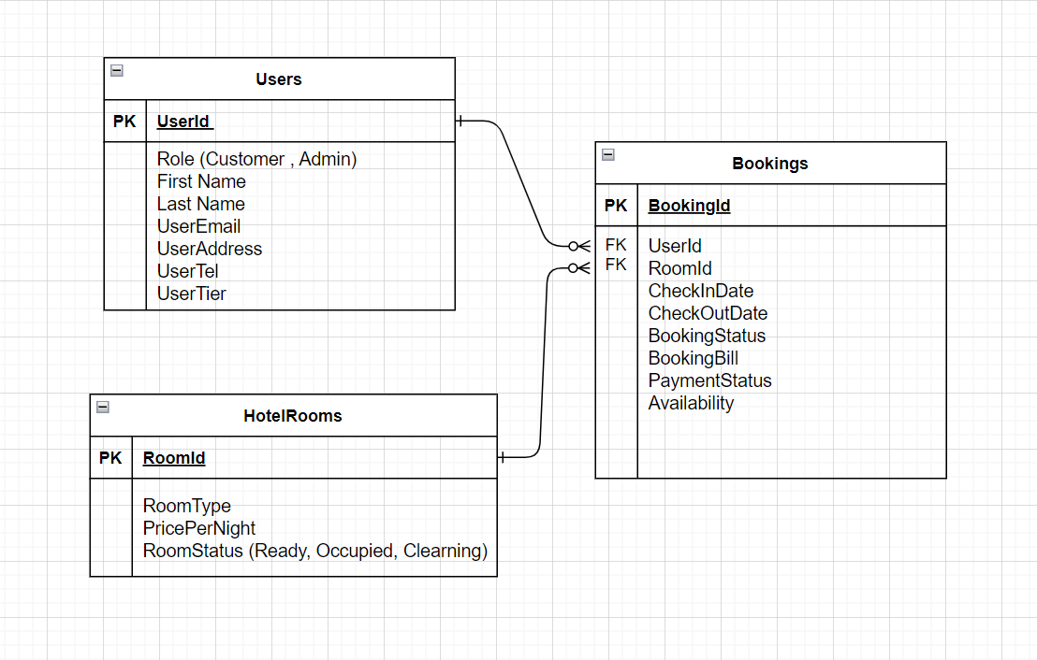

## Figure: Case diagram with two actors performing actions

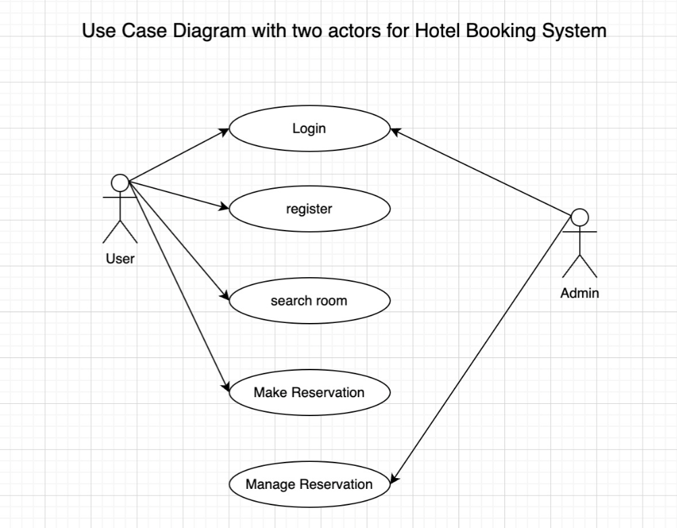

## Mockups of web pages

### The Homepage:

* About us: provide the basic information about the booking system
* Book Now: the booking page where the customer can reserve the room of their choice.

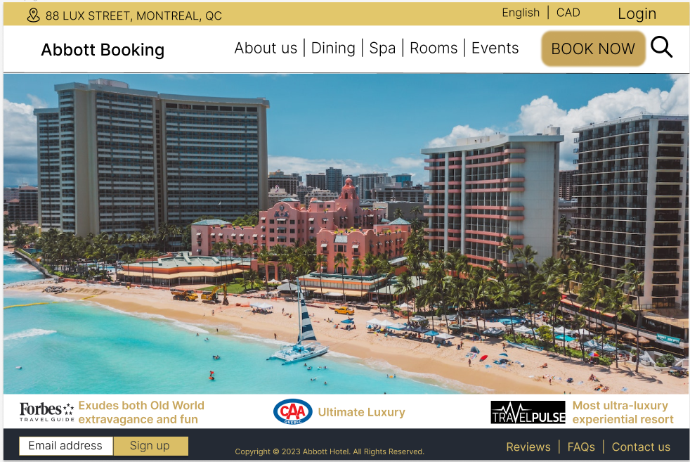

### The Rooms:

* Users view the details of room type, availability and price
* Rooms reservations

